# Testing

## Test 1

Story: A user logs onto the system and creates a balance sheet for today’s date.

This is the startup screen:

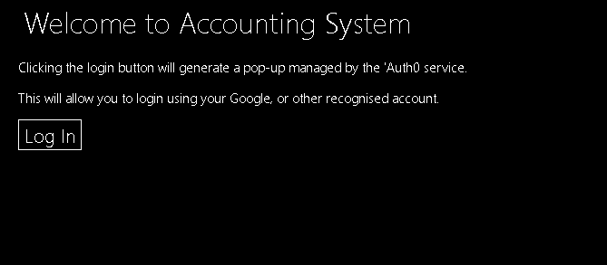

When Log in is clicked the window below pop’s up.

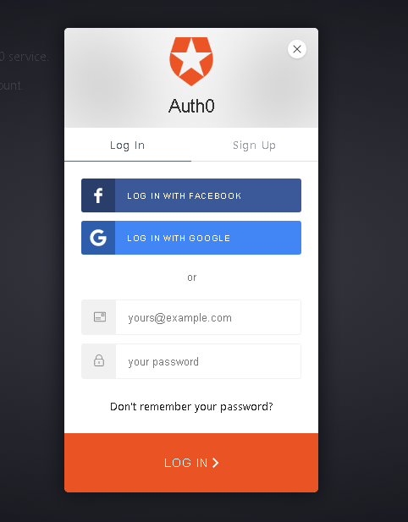

After logging in with valid credentials the Home screen (below) is displayed.

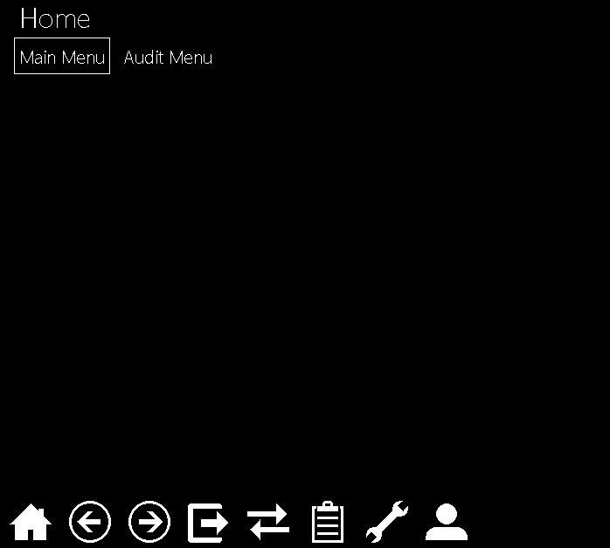

The user can select between two different menu’s, after selecting Main menu the below options are shown.

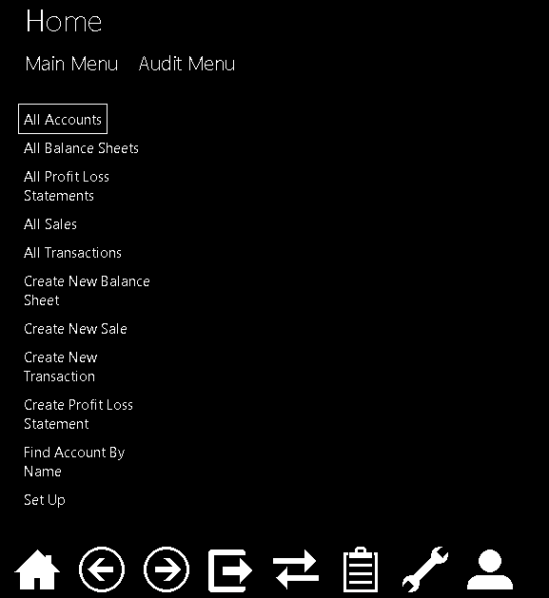

When Create New balance sheet is clicked the below form pop’s up and requires filling.

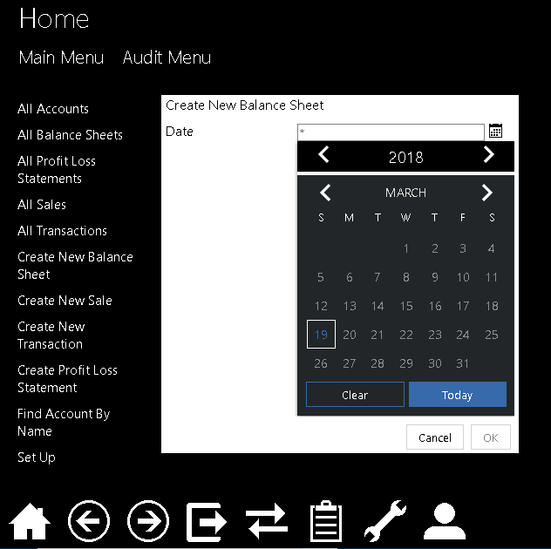

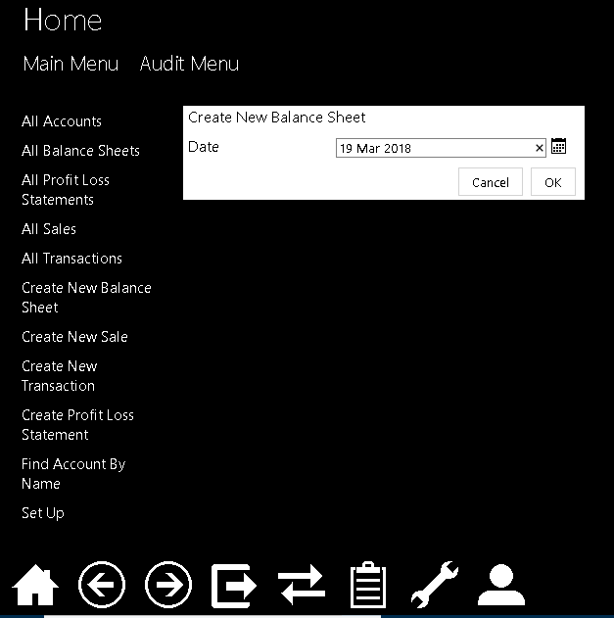

The form is filled and ‘ok’ is clicked to create the balance sheet, it is then displayed as shown below:

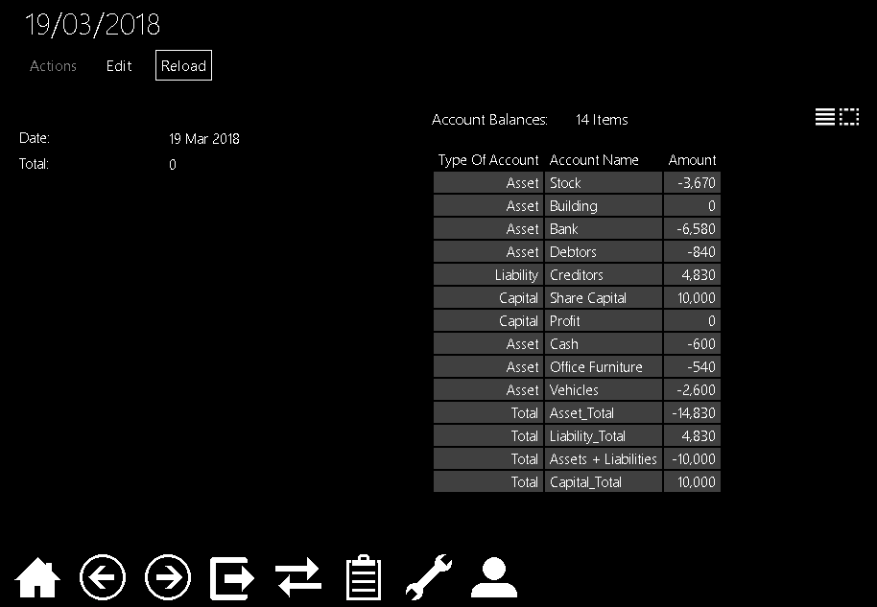

## Test 2